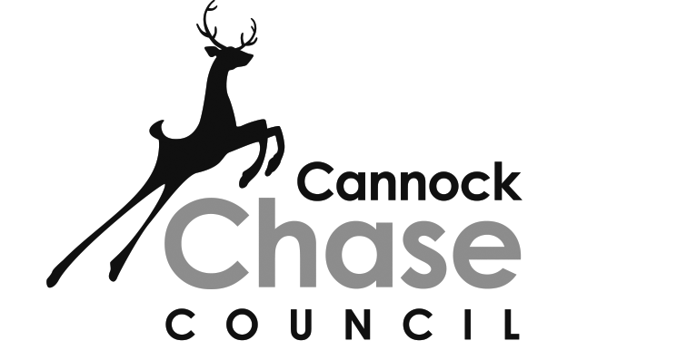
PLANNING AND COMPULSORY PURCHASE ACT 2004
TOWN AND COUNTRY PLANNING REGULATIONS (LOCAL PLANNING) (ENGLAND) (2012) REGULATION 26

CANNOCK CHASE LOCAL PLAN – LOCAL PLAN (PART 1)
DEVELOPMENT PLAN DOCUMENT ADOPTION STATEMENT: JUNE 2014

Notice is hereby given that Cannock Chase Council resolved to adopt the Cannock Chase Local Plan – Local Plan (Part 1) Development Plan Document on 11th June 2014.

The Local Plan (Part 1) replaces the ‘saved’ policies of the 1997 Local Plan and sets out the strategic framework for development in the District for the period 2006-2028. The Local Plan (Part 1) has been subject to examination by an independent inspector appointed by the Secretary of State and a number of modifications were made to the Local Plan (Part 1) Proposed Submission Document 2013, as set out in Appendix 1 of the Inspector’s Report. Pursuant of section 23(3) of the Planning and Compulsory Purchase Act 2004, the adopted Local Plan (Part 1) incorporates these modifications.

Any person aggrieved by the adoption of the Local Plan (Part 1) may make an application to the High Court under Section 113 of the Planning and Compulsory Purchase Act on the grounds that:

- the Local Plan is not within the powers conferred by Part 2 of the Planning and Compulsory Purchase Act 2004;
- a procedural requirement of the Planning and Compulsory Purchase Act 2004 or its associated Regulations has not been complied with.

Any such application should be made promptly and in any event no later than the end of the six week challenge period, starting with the date on which the plan was adopted (11th June 2014).

The Local Plan (Part 1), this adoption statement, the sustainability appraisal report (and corresponding adoption statement) and the Inspectors report are all available for public inspection on the Council website at www.cannockchasedc.gov.uk/planningpolicy and at the following locations* during normal opening hours:

- Cannock Chase Council principal offices at the Civic Centre, Beecroft Road, Cannock
- Public libraries at Cannock, Rugeley, Hednesford, Brereton, Norton Canes and Heath Hayes
- Council Area Office at Rugeley

Further information is available by contacting the Planning Policy team by email at planningpolicy@cannockchasedc.gov.uk or by telephoning 01543 462621.

*Please note that the Sustainability Report (and corresponding adoption statement) is only available to view at the Council’s principal offices, Civic Centre, Beecroft Road, Cannock.

