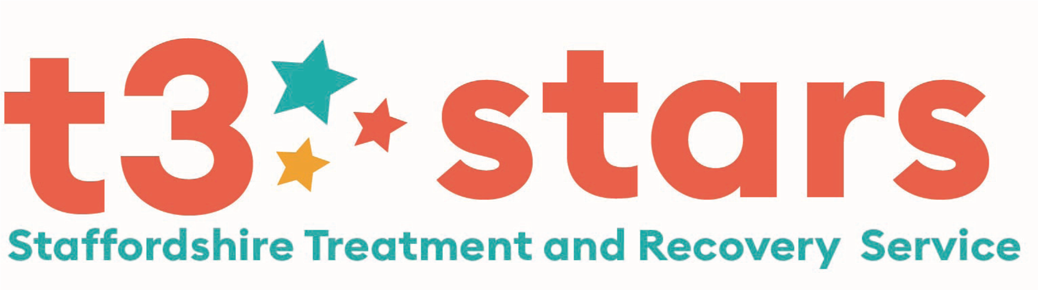
Young Person’s Substance Misuse Service
HIDDEN HARM REFERRAL FORM
Fields with * MUST be Completed Please

1 | Essential Criteria for Acceptance of Referral: (if you answer ‘No’ to any of the questions in Box 1, please contact us to discuss further)  *Is the young person aware of this referral? Yes € No € & *Do they agree to this referral? Yes € No €
2 | *Are the young person’s parents/carers aware of this referral? Yes € No €  (please note: the parental consent form is required for a young person under the age of 13 years)
3 | Do you feel this young person would benefit from an initial ‘Introduction session’ to learn more about the service we offer  and how we can support them? Yes € No €
4 | Referrers Name: |  |  | Organisation: |  | Role:
 | Address:
 | Contact Tel No: |  |  | E Mail Address: |  | Person to contact in your absence:
5 | Client Name:  Address:  Postcode:  Contact Tel No:  Date of Birth: Age:  Gender: Ethnicity:  Contact number for Parent/Carer (if appropriate):  *Can the young person be contacted at home? Yes € No €  *Who does the Young Person live with?  *Where would be the best venue to meet the Young Person?  *Are there any risks in visiting the home? Yes € No €  Please record detail of risks |  |  |  | Client’s Education Status:  Name of school / college:
Is the client receiving mental health treatment? Yes € No €
Professional working with client:

Does the client have learning / Disability needs?
Please provide details:

Is the young person engaging in Offending Behaviour?
Yes € No €
Please provide details

Is the young person at risk of Exploitation? Yes € No €
CSE € CCE € DUAL €

Has a Risk Factor Matrix been completed? Yes € No €

Risk level on Matrix Low € Medium € High €

Please provide details:
6 | FAMILY / CARER SUBSTANCE USE (Drug and alcohol)
Is the young person aware of the substance use within the family? |  | Name of parent / family member using substances |  | Substances being used | What is the impact of the substance use on young person?  What knowledge does the young person have around the substance use?
YES € NO €
Referrals will only be considered if the young person is aware of the substance use.
7 | *SAFEGUARDING
Are there any Safeguarding concerns? Yes € No € Is the young person on a Child Protection Plan? Yes € No €

Is the young person on a Child In Need Plan? Yes € No € Is the young person a Looked After Child? Yes € No €

Social Workers name __________________________________ Contact details:_________________________________________

Please detail reason for involvement or Safeguarding concerns:

Continued……….

*STRENGTHS AND PROTECTIVE FACTORS*

Please record what strengths the young person has and the protective factors in place:

*ADDITIONAL INFORMATION*

Identified Risks: Safeguarding, Risks to home visiting, Risk to worker, Exploitation, overdose, injecting, offending, physical/mental health issues, binge use, & Any Other Relevant Information

Please record any extra information to support the referral:

Is an Interpreter required? Yes € No € If so, for which language? _____________________________

Please submit your referral:

By Post - Suite 1, 7-8 Mill Street, Stafford. ST16 2AJ.

Tel: 01785 241393

E mail: t3stars.stafford@humankindcharity.org.uk

